Computer Language Coding Concepts

Related Item in a Diagram
The concept of related item is explained in the article Related Item. The current article demonstrates it in a diagram.

A relation to another object is part of the parent object. A parent object is a real object. Its related item is not a real object, but a pointer to an object. The system interface of a related item determines which object the parent will refer to.

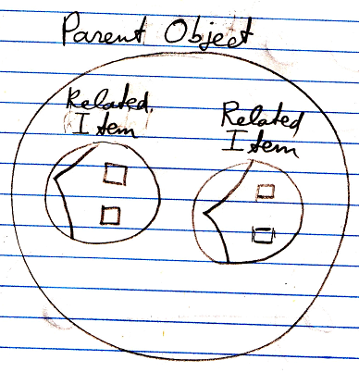

The pointers, so the sytem interfaces, are part of the parent object.

The article Related Item mentions decorating assignment and retrieval of a related item with extra procedures. That concept will be demostrated with diagrams by the article Extending the System Interface.

The article Related Item mentions pointing not to a specific object, but to another →1 related item or →n related list item. That concept will be demonstrated with diagrams in the article Pointer to Pointer in a Diagram.

See also: Related Item, Pointer to Pointer in a Diagram

Author & Copyright: Jan-Joost van Zon Date: July 18, 2008 – July 18, 2008 Location: Oosterhout, The Netherlands Status: Finished

